**WEEKLY REPORT DE BENEDETTI MATTEO**

**WEEK 2: 16/09/2019 – 20/09/2019**

ADDED PRERECORDED CONTROL:

Written a script [1] to run the Visual Odometry on a prerecorded sequence of controls with the joystick, with the objective of improving consistency across multiple tests.

FIRST TESTS:

Performed a first sequence of tests with a straight trajectory and varying the translational velocity.

Three control sequences were produced to move the rover for 3 meters at different speeds:  
log 20190919-1628: translation velocity = 0.15 m/s  
log 20190919-1352: translation velocity = 0.45 m/s  
log 20190919-1359: translation velocity = 0.65 m/s

A Matlab script allows to quickly visualize and compare the results [2]



The results show that, with the current values of exposure time, velocity does not seem to affect the VO error that grows at the same rate in all three cases.

It is also important to see that there is clearly a relevant error in the first step of the VO algorithm.  
This has been further investigated with other tests and it has been observed that, almost on every occasion, the first iteration fails and does not converge, resulting in a big error at the very beginning that cannot be recovered.  
This leads to relatively large errors (around 5% of the traveled distance) compared to the current state of the art (2% error of the travelled distance) [3].

CAMERA CALIBRATION:

Further tests have shown a possible correlation between the direction of movement and the error in the pose estimated by the VO.  
This and the drift on the z axis suggest a possible miscalibration of the camera.



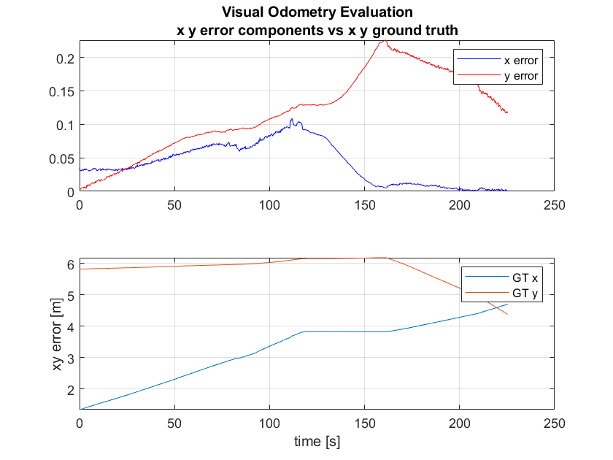

Also, from a visual inspection of the rover, the camera munt seems slightly unstable and may contribute to the camera miscalibration.

FUTURE OBJECTIVES:

Understanding and possibly fixing or at least mitigate the error in the first step of the VO algorithm to reduce the initial offset in position and orientation.

Study the performance of the VO algorithm in terms of heading angle.

Recalibrate the camera and 3D printing a new camera mount.

BIBLIOGRAPHY

[1] <https://github.com/esa-prl/bundles-exoter/blob/master/scripts/nojoy_visodom.rb>

[2] <https://github.com/MatteoDeBenedetti/ESA-Thesis/blob/master/VO_logs_visualization/compare_tests.m>

[3] Clarification of performance metrics for SFR Breadboarding. AIRBUS